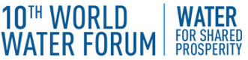 | 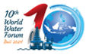 | 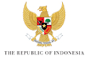

KICK-OFF MEETING of the 10TH WORLD WATER FORUM
BREAKOUT SESSION – WATER FOR HUMANS AND NATURE.

TABLE SHEET

Using keywords, please name the five or six most relevant topics that could be addressed by the Theme WATER FOR HUMANS AND NATURE.

1.

2.

3.

4.

5.

6.

