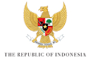

KICK-OFF MEETING of the 10TH WORLD WATER FORUM
BREAKOUT SESSION – WATER SECURITY AND PROSPERITY

RAPPORTEUR SHEET

What are the five most important issues that should be addressed by the Theme “Water Security & Prosperity”?

1.

2.

3.

4.

5.

6.

