 | 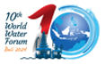 | 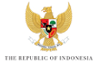

KICK-OFF MEETING of the 10TH WORLD WATER FORUM
BREAKOUT SESSION – WATER SECURITY AND PROSPERITY

TABLE SHEET

Using keywords, please name the five or six most relevant topics that could be addressed by the Theme WATER SECURITY & PROSPERITY.

1.

2.

3.

4.

5.

6.

