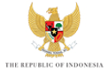

KICK-OFF MEETING of the 10TH WORLD WATER FORUM

BREAKOUT SESSION – DISASTER RISK REDUCTION AND MANAGEMENT

RAPPORTEUR SHEET

Which are the five most important issues that should be addressed by the Theme “DISASTER RISK REDUCTION AND MANAGEMENT”?

1.

2.

3.

4.

5.

6.

