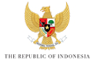

KICK-OFF MEETING of the 10TH WORLD WATER FORUM

BREAKOUT SESSION – COOPERATION AND HYDRO-DIPLOMACY

RAPPORTEUR SHEET

What are the five most important issues that should be addressed by the Theme “COOPERATION AND HYDRO-DIPLOMACY”?

1.

2.

3.

4.

5.

6.

