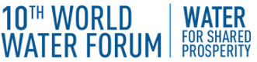 | 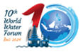 | 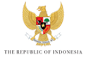

KICK-OFF MEETING of the 10TH WORLD WATER FORUM

BREAKOUT SESSION – COOPERATION AND HYDRO-DIPLOMACY

TABLE SHEET

Using keywords, please name the five or six most relevant topics that could be addressed by the Theme COOPERATION AND HYDRO-DIPLOMACY.

1.

2.

3.

4.

5.

6.

