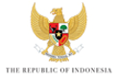

KICK-OFF MEETING of the 10TH WORLD WATER FORUM

BREAKOUT SESSION – KNOWLEDGE AND INNOVATION

RAPPORTEUR SHEET

What are the five most important issues that should be addressed by the Theme KNOWLEDGE AND INNOVATION?

1.

2.

3.

4.

5.

6.

